Name: Ly Tan Loi
ID: SE62155
LAB 3 – Configuring RIP

I. Objectives
- configure RIP routing on the routers, to have a good understanding of a routing algorithm.

II. Prerequisites
- Chapter 3.
- Cisco Packet Tracer is a powerful network simulation program that allows students to experiment with network behavior. If you have not done so already, you are encouraged to obtain Packet Tracer from menu Help > Tutorials (F11).
- Basic router configuration tutorial, here.

III. Report
My report contains:
- My work in Packet Tracer Network file (Lab3.pkt)
- document the RIP configuration, output from the verify RIP routing commands.
IV. Lab
1. Topology Diagram
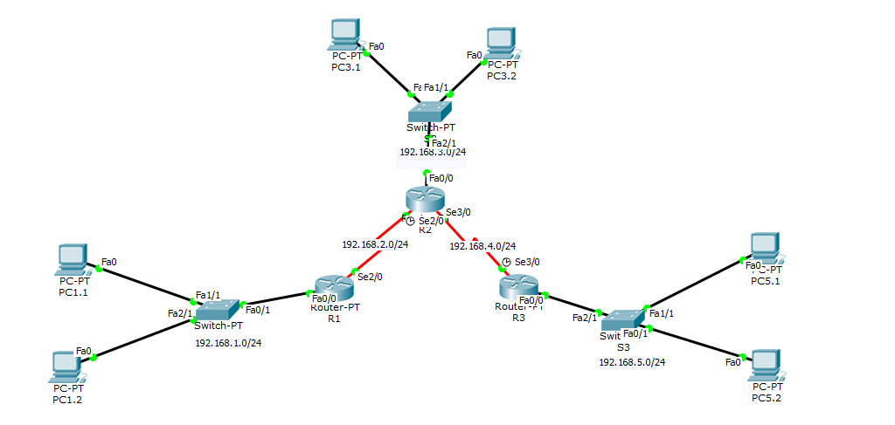

2. Addressing Table
Device | Interface | IP Address | Subnet Mask | Default Gateway
R1 | Fa0/0 | 192.168.1.1 | 255.255.255.0 | N/A
R1 | Se2/0 | 192.168.2.1 | 255.255.255.0 | N/A
R2 | Fa0/0 | 192.168.3.1 | 255.255.255.0 | N/A
R2 | Se2/0 | 192.168.2.2 | 255.255.255.0 | N/A
R2 | Se3/0 | 192.168.4.2 | 255.255.255.0 | N/A
R3 | Fa0/0 | 192.168.5.1 | 255.255.255.0 | N/A
R3 | Se4/0 | 192.168.4.1 | 255.255.255.0 | N/A
PC1.1 | NIC | 192.168.1.10 | 255.255.255.0 | 192.168.1.1
PC1.2 | NIC | 192.168.1.11 | 255.255.255.0 | 192.168.1.1
PC3.1 | NIC | 192.168.3.10 | 255.255.255.0 | 192.168.3.1
PC3.2 | NIC | 192.168.3.11 | 255.255.255.0 | 192.168.3.1
PC5.1 | NIC | 192.168.5.10 | 255.255.255.0 | 192.168.5.1
PC5.2 | NIC | 192.168.5.11 | 255.255.255.0 | 192.168.5.1

3. Prepare the Network
*Router: 3 PT10000
*Switch: 3 PT3000
*Clients: 6 PCs
4. Configure and Activate Serial and Ethernet Addresses
*Step1: Configure the router hostname:
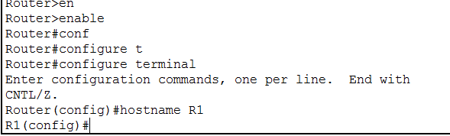
Similarly, configure hostname for R2 and R3.
*Step2: Configure the interfaces on the R1, R2, and R3 routers with the IP addresses from the Addressing table.
*Step4:When you have finished, be sure to save the running configuration to the NVRAM of the router, use write command.
*Step5: Configure the Ethernet interfaces of PC1, PC2, and PC3 with the IP addresses and default gateways from the Addressing table.
*Step 6: Test the PC configuration by pinging the default gateway from the PC.

5. Configure RIP

*Step 1: Configure RIP on the R1, R2, and R3 router.
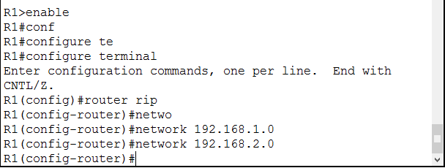
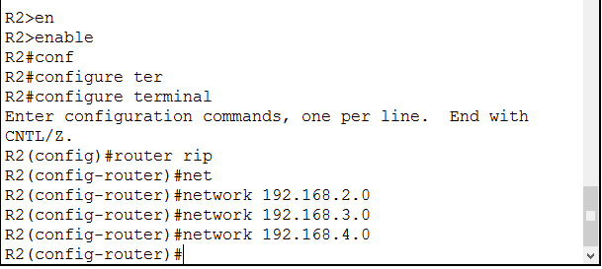
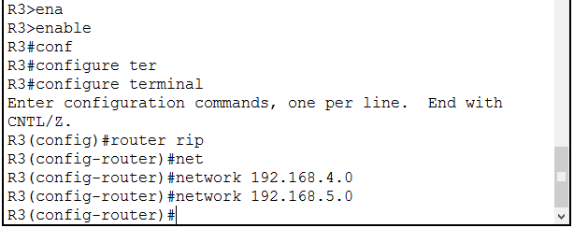
*Step 2: Save the current configuration to NVRAM.
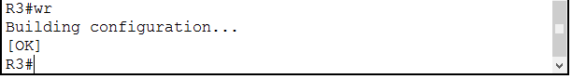

6. Verify RIP Routing
-Step 1: Use the show IP route command to verify that each router has all of the networks in the topology entered in the routing table.
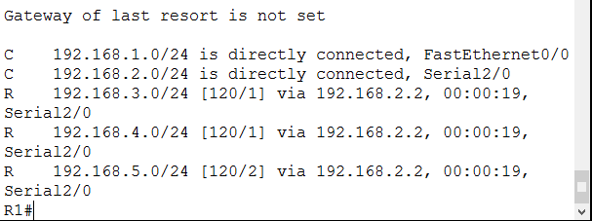
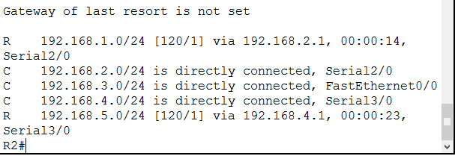
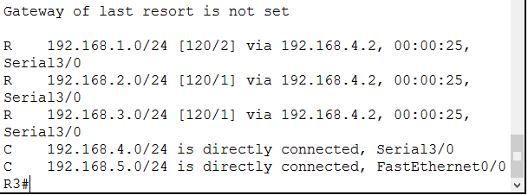
Step 2: The show IP protocols command can be used to view information about the routing processes that are occurring on the router. This output can be used to verify most RIP parameters to confirm that:
• RIP routing is configured
• The correct interfaces send and receive RIP updates
• The router advertises the correct networks
• RIP neighbors are sending updates
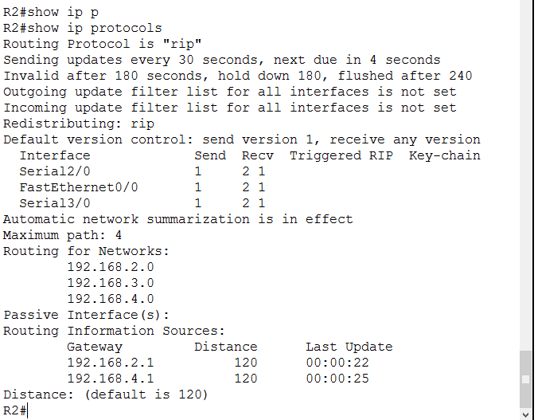
Step 3: Use the debug IP rip command to view the RIP messages being sent and received.

